T & K E-Channel CRM Project
BroadVision Community Definition and Rules Based Matching

Document Control

Revision History

Author | Version | Date | Description of Change
Geoff Lyle | 1.0 | February 1, 2000 | First release
Geoff Lyle | 1.1 | February 14, 2000 | Addition of Rulesets, rules and content

Distribution
Name | Location
Roger Haddon | T&K
Ros Rosewarne-Jenkins | T&K
Amar Shabbir | T&K
Simon Morgan | T&K
Iain Williamson | T&K
Bob Sherlock | T&K

BroadVision User Profile Definition and Enhancements
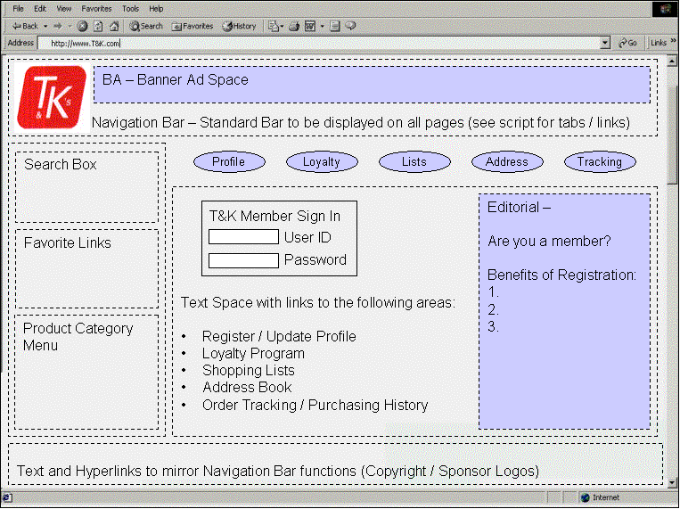
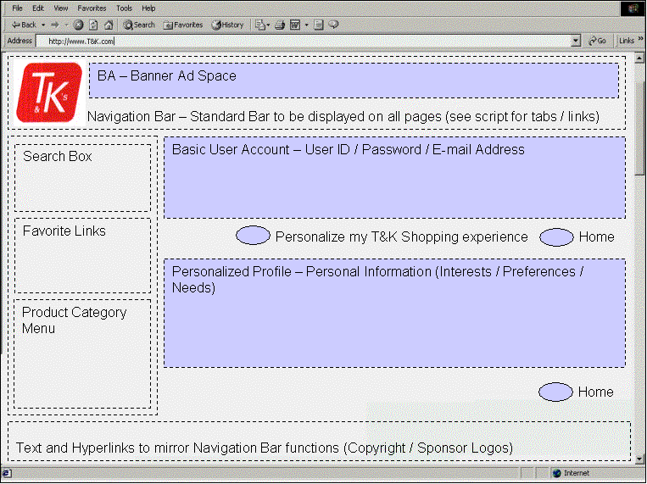
In order to define customer segments known as “communities” within BroadVision, we must build a profile creation / maintenance application for the T&K website. The customer profile will be based primarily on the delivered BV_USER_PROFILE table for standard demographic attributes. However, in order to identify customer preferences that will drive of personalization of the web site we are required to modify the delivered table and to add list tables that support our needs.

The customer record can be broken down into three sections:
- Basic User Account - This will include a unique customer ID, password, e-mail address, and T&K loyalty card account number.
- Transactional data - Required data needed to support completion of a sales order. (Billing address, shipping address, and payment information)
- Personalized data – Combination of demographic and psychographic attributes combined to define the customer segments that will drive personalization of the website.

Basic User Account

The T&K profile questionnaire will ask the following “basic” questions:
- Please provide your First and Last Name
- Please provide your e-mail address
- Please select a unique User Id
- Please create a password and confirm your password
- Are you member of the loyalty card program, and if so please provide your card number

At this point we have enough information to create a simple user account and begin observational tracking of the user. We can base some basic matching at this point, and treat the customer as member of some default community until they provide us with either meaningful observations, purchasing history, or decide to offer us personal content by way of filling out the customer profile questionnaire.

Transactional Data
T&K will be able to obtain transactional data from the customer in three ways.
- The customer will make a purchase from the website, and in so doing will be required to provide us with billing and address information as a criteria for completing the sales transaction.
- The customer is already a member of the Loyalty card program, and we identify the customer as such. We will have some name and address information as well as purchasing history from other channels.
- The customer will tell us their address when they fill out their profile information.

Personalized Data
Customers will be prompted to fill out a customer profile that will tell us some of the family details, demographics and personal shopping preferences. We will ask the following questions:
- Address (if known it will be populated automatically)
- Gender
- Age Range
- Number of adults in household
- Number of children in Household
- Food Brand Preference (Do you like brands or Generics)
- Fashion Brand Preference (Do you like brands or Generics)
- Price Preference (Do like Coupons / Sales or Every Day Low Price)
- Functional preference (Functional vs. Luxury)
- Preferred merchandise categories
- Contact method (e-mail, direct mail)
In addition, to display taxonomy matching using the BroadVision matching engine we will ask customer who indicate a preference for the entertainment category of merchandise to fill out some additional questions regarding their movie preferences. Customer will be asked to rate how they feel about certain types of movies (action, mystery / suspense, classics, comedies, romantic comedies), and whether or not they purchase children’s videos.

RSC E-channel Customer “Community” Definitions:

The information gathered from the customer profile will be used to segment customers. Four BroadVision Communities will be defined using a combination of demographic and psychographic attributes from the table BV_USER_PROFILE and an associated list table to be created. The Four communities are defined as follows:
- Bargain Hunters:
- Prefer sales and coupons
- Buy Branded goods when on sale, generics otherwise
- Rarely buy luxury items
- All families in middle and down markets
- Impulse Buyers:
- Buy on an Every Day Fair Price basis, rarely use coupons
- Prefer brands over generics
- Tend to splurge on luxury items in each category
- Young couples and singles in middle and up markets
- Time Starved:
- Will use coupons as available, less than average
- Prefer brands, never buy generics
- Purchase basic goods, rarely splurge
- Families and households in middle and up markets
- Budget Conscious:
- Use coupons and buy sales items with average frequency
- Mostly purchase generics
- Purchase basic goods, rarely splurge
- Younger parents in middle and down markets and older households in all markets

Demographic Community Attributes:

Demographic elements are obtained from the table BV_USER_PROFILE, and will require no modifications to the table as delivered.
FIELD | TABLE | DESCRIPTION | VALUES
GENDER | BV_USER_PROFILE | User gender | - Male, Female
AGE_RANGE | BV_USER_PROFILE | User age range | - 18 to 25, 25 to 34, 35 to 44,  45 to 54, 55 to 64, 65+
NO_HOUSEHOLD | BV_USER_PROFILE | Number of People in Household. Will be used to store the number of adults in the household | - Integer Value

Psychographic / Behavioural Community Attributes:
Enhancements to the user profile delivered by BroadVision will be in two forms. We will extend the current definition of BV_USER_PROFILE to include new attributes at the user level. Additionally we will add a list table to store pyschographic and taxonomy attributes at the user / category level. This will allow a customer to express different preferences for the same attribute across categories, allowing a customer to switch community membership dynamically; based on the category of merchandise they are shopping. We can then allow a customer to indicate brand preference across categories where a customer may have opposite preferences between two categories. For example, a customer may be very brand sensitive in clothing departments, shopping only for designer merchandise, but be indifferent to brand when shopping for food items. For demonstration purposes category specific attributes will be stored at the four top-level merchandise categories initially. (Entertainment, Home Wares, Fashion, Food & Drink). It should also be stated that stating of direct questions about preferences might not be a preferred method for obtaining this type of data. Intuitive mining of the purchasing history and observational data should be investigated as a means for determining the values of many customer specific attributes. From the profile outline above, income range and brand preference, Functional preference would be excellent candidates for attributes to be mined from monitoring customer behaviour. However, in the future, the profile maintenance screen could be modified to allow storage of attributes at any category within the BroadVision merchandise hierarchy. This would not require modification of the database. The new table definitions are outlined below.
BV_USER_PROFILE - Extensions
FIELD | TABLE | DESCRIPTION | VALUES
NO_CHILD_HSHLD | BV_USER_PROFILE | Number of People in Household. Will be used to store the number of adults in the household | - Integer Value
PRICE_PREF | BV_USER_PROFILE | User price preference. True = I prefer coupons  False = I prefer EDLP | (T/F)

LIST_USER_PREF
FIELD | TABLE | DESCRIPTION | VALUES
USER_ID | BV_ USER_TK_PREF | User id from BV_USER_PROFILE | Valid user ID’s from BV_USER_PROFILE
CAT_OID | BV_ USER_TK_PREF | Category ID from BV_CATEGORY | Valid category OID’s from BV_CATEGORY
BRAND_PREF | BV_ USER_TK_PREF | User Brand preference:  True = I like brands  False = I like generics | (T/F)
FUNCTION_PREF | BV_ USER_TK_PREF | Taxonomy value for general functional purpose of the item (i.e., is it a luxury good, or is it more basic / functional) | Customer selects a value of 1 to 5 to indicate the functionality of goods they prefer (i.e.: 1 meaning customer prefers functional items high quality at a good value vs. 5 meaning customer prefers luxury goods
ACTION | BV_ USER_TK_PREF | Taxonomy value | Customer choices range from strongly disagree to strongly agree, and are translated to a value from `1 to 5 in the DB.
SUSPENSE | BV_ USER_TK_PREF | Taxonomy value | Customer choices range from strongly disagree to strongly agree, and are translated to a value from `1 to 5 in the DB.
COMEDY | BV_ USER_TK_PREF | Taxonomy value | Customer choices range from strongly disagree to strongly agree, and are translated to a value from `1 to 5 in the DB.
ROMANCE | BV_ USER_TK_PREF | Taxonomy value | Customer choices range from strongly disagree to strongly agree, and are translated to a value from `1 to 5 in the DB.
CLASSIC | BV_ USER_TK_PREF | Taxonomy value | Customer choices range from strongly disagree to strongly agree, and are translated to a value from `1 to 5 in the DB.
CHILDREN | BV_ USER_TK_PREF | T/F value initially used in video to indicate a preference for purchasing children’s items. Can be used in any category if the profile and questions are set-up online to support the attribute in other categories | (T/F)

Community Definition: The BroadVision Criteria Statement

In order to define the communities listed above in BroadVision, the descriptions of the customer preferences must be represented as a database query that will produce a sub-set of the customers stored in the BV_USER_PROFILE table.

- Bargain Hunters:
  - GENDER (N/A)
  - AGE_RANGE (NA)
  - NO_HOUSEHOLD >=1
  - NO_CHILD_HSHLD >=1
  - PRICE_PREF = T
  - FUNCTION_PREF <=3
  - BRAND_PREF = F

- Impulse Buyers:
  - GENDER (N/A)
  - AGE_RANGE <=35
  - NO_HOUSEHOLD <=2
  - NO_CHILD_HSHLD <1
  - PRICE_PREF = F
  - FUNCTION_PREF >=4
  - BRAND_PREF = T
- Time Starved:
  - GENDER (N/A)
  - AGE_RANGE (NA)
  - INCOME_RANGE >=30,000
  - NO_HOUSEHOLD >=1
  - NO_CHILD_HSHLD >=1
  - PRICE_PREF = T
  - FUNCTION_PREF <=3
  - BRAND_PREF = F
- Budget Conscious:
  - GENDER (N/A)
  - AGE_RANGE (N/A)
  - NO_HOUSEHOLD >=1
  - NO_CHILD_HSHLD (
  - PRICE_PREF = T
  - FUNCTION_PREF <=2
  - BRAND_PREF = F

Content Table Modifications
In order to support the matching process within BroadVision, content tables will also need to be modified to support custom attributes. For the T&K website, we will add a list table to the Product data model, and extend the advertisement table to support two additional attributes.
BV_PRODUCT_TK
FIELD | TABLE | DESCRIPTION | VALUES
BRAND | BV_ PRODUCT_TK | True = Brand  False = Generic / NA | (T/F)
FUNCTION_PREF | BV_ USER_TK_PREF | Taxonomy value for general functional purpose of the item (i.e., is it a luxury good, or is it more basic / functional) | Each product using this value must be ranked 1 to 5 inorder to indicate the function of the good.
ACTION | BV_ USER_TK_PREF | Taxonomy value | Customer choices range from strongly disagree to strongly agree, and are translated to a value from `1 to 5 in the DB.
SUSPENSE | BV_ USER_TK_PREF | Taxonomy value | Customer choices range from strongly disagree to strongly agree, and are translated to a value from `1 to 5 in the DB.
COMEDY | BV_ USER_TK_PREF | Taxonomy value | Customer choices range from strongly disagree to strongly agree, and are translated to a value from `1 to 5 in the DB.
ROMANCE | BV_ USER_TK_PREF | Taxonomy value | Customer choices range from strongly disagree to strongly agree, and are translated to a value from `1 to 5 in the DB.
CLASSIC | BV_ USER_TK_PREF | Taxonomy value | Customer choices range from strongly disagree to strongly agree, and are translated to a value from `1 to 5 in the DB.

BV_ADVERTSIEMENT – Extensions
FIELD | TABLE | DESCRIPTION | VALUES
BRAND | BV_ PRODUCT_TK | True = Brand  False = Generic / NA | (T/F) Is this a branded ad?
MARKET | BV_ USER_TK_PREF | STRING value to indicate the market (audience) for the ad. | - Up Market  - Middle Market  - Down Market

BroadVision Rule Sets
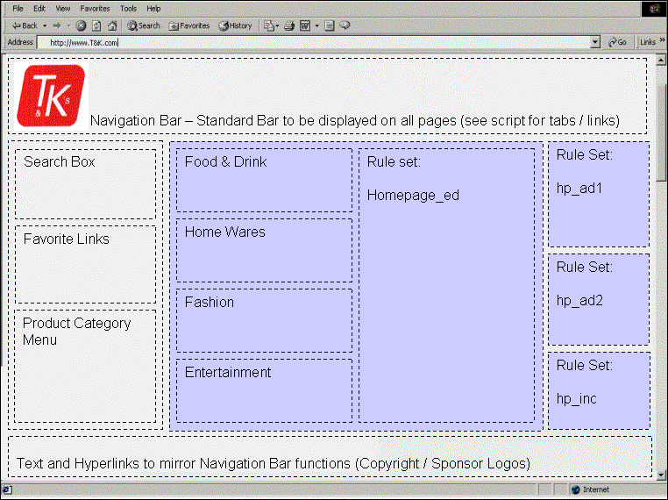
BroadVision rule sets are used to define groups of rules that will be used in specific JavaScript page scripts to be developed by the RSC team. JavaScript code is used to develop dynamic pages that will display personalized information based on the community of the visitor to the site. As a result of the planning and analysis phase of the RSC E-channel project we have identified 13 distinct instances where BroadVision rule sets will be called by to display personalized information on various pages within the T&K web site. Those instances are detailed in the following list. Section 5 will discuss the actual rules to be used and the content being developed that will be displayed as a result of the matching process.

- Home Page rule sets
- homepage_ad1
- homepage_ad2
- homepage_inc
- homepage_ed

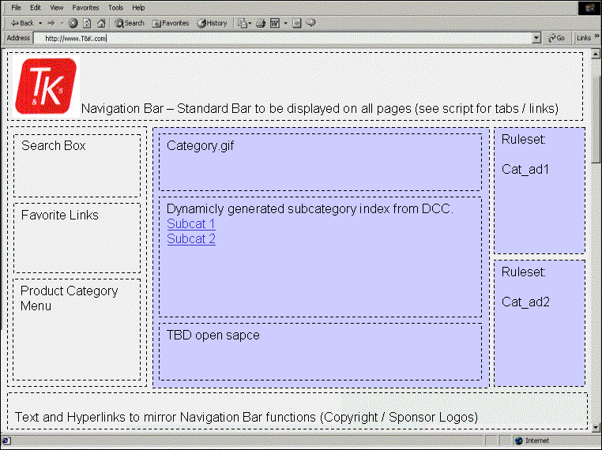
- Category and Sub-category Page rule sets
  - category_ad1
  - category_ad2

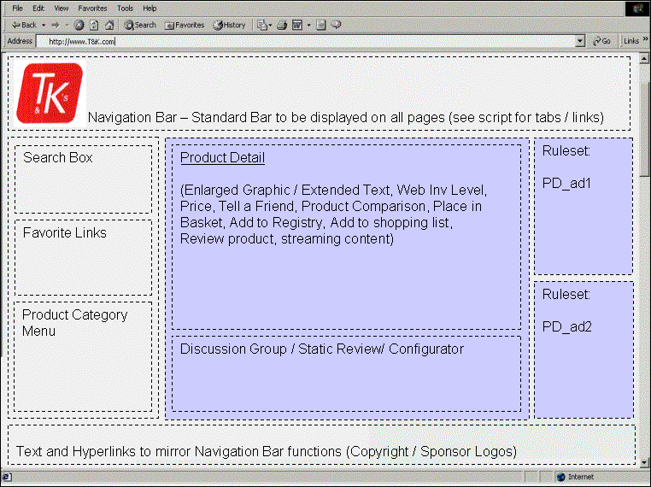
- Product Detail Page rule sets
- product_ad1
- product_ad2

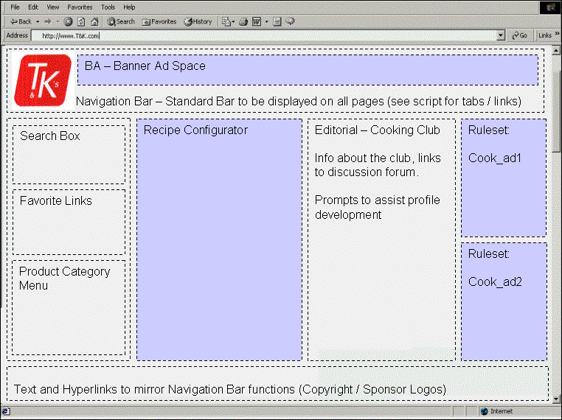
- Cooking Club rule sets
- cookclub_ad1
- cookclub_ad2

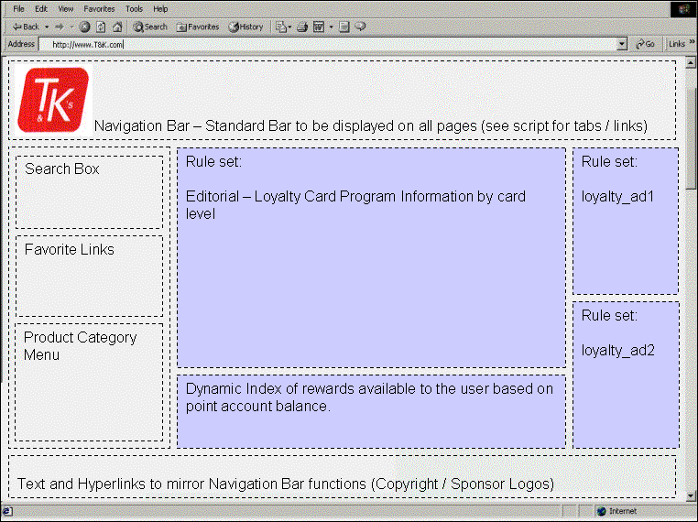
- Loyalty Card Review Page rule sets
- loyalty_ad1
- loyalty_ad2
- loyalty_ed

Rules and Content
Using the rule sets defined above, we will create rules for each community (Impulse Buyers “IB”, Bargain Hunters “BH”, Time Starved Professionals “TS”, Budget Conscious “BC”) and a default rule initially. The rules listed here are for planning purposes, the dynamic nature of BroadVision allows these rules to be modified at any time in response to changing business conditions or marketing iniatives.
Home Page Rules
Rule set: homepage_ad1 – Ad space 1 on the homepage (upper right)
Content Type: Advertisement
Community | Rule | Content
Bargain Hunters | Select specific item from advertisements | Levis on-sale
Impulse Buyers | Select specific item from advertisements | High end Branded ad
Time Starved | Select specific item from advertisements | Create a shopping list ad
Budget Conscious | Select specific item from advertisements | T&K brand ad
Default | Select specific item from advertisements | Loyalty card program registration

Rule set: homepage_ad2 – Ad space 2 on the homepage (middle right)
Content Type: Product
Community | Rule | Content
Bargain Hunters | Select weekly special product from preferred category | product.gif with link
Impulse Buyers | Select Product from luxury | product.gif with link
Time Starved |  | product.gif with link
Budget Conscious | Select weekly special product from preferred category | product.gif with link
Default | Select any product from weekly specials | product.gif with link

Rule set: homepage_inc – Incentive space on the homepage (lowerright)
Content Type: Incentive
Community | Rule | Content
Unregistered | Id user has no profile information | Display registration incentive
Bargain Hunters
Impulse Buyers
Time Starved
Budget Conscious
Default

Rule set: homepage_ed – Editorial space on the homepage (middle)
Content Type: Incentive
Community | Rule | Content
Bargain Hunters | Select specific editorial | BH Editorial
Impulse Buyers | Select specific editorial | IB Editorial
Time Starved | Select specific editorial | TS Editorial
Budget Conscious | Select specific editorial | DM Editorial
Default | Select specific editorial | Default Editorial

Category / Sub-category Rule Sets
Rule set: category_ad1 – Ad space on categrory and sub-category pages (upper right)
Content Type: Product
Community | Rule | Content
Bargain Hunters | Select product appropriate the community | Product.gif and desc.
Impulse Buyers | Select product appropriate the community | Product.gif and desc.
Time Starved | Select product appropriate the community | Product.gif and desc.
Budget Conscious | Select product appropriate the community | Product.gif and desc.
Default | Random pick from X category | Product.gif and desc.

